**Stem Cell Research Assignment**

[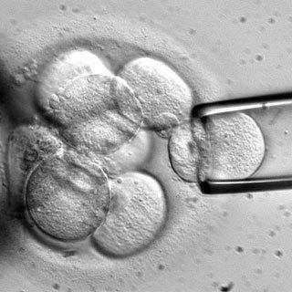](http://www.google.com.au/url?sa=i&rct=j&q=therapeutic+cloning&source=images&cd=&cad=rja&uact=8&docid=DPvjax1G2_QoIM&tbnid=oAxdY6wNPxZvdM:&ved=0CAUQjRw&url=http://monkey123kylefortune.wix.com/therapeutic-cloning&ei=FgOpU5-eJ8SGkAWO0YCoDQ&psig=AFQjCNGQiBilCHraOfRNX7kek5jPcfz56Q&ust=1403671692370063)

Name: ____________________________ Date:_____________________ /25

You are taking this question sheet and the related information home before the assessment date to give you time to read the information thoroughly, do some research and to prepare for the assessment.

You will bring this information and your text book to class. You may make notes on your sheets but not prepared answers. You will be expected to answer the questions in class.

Please write your answers on lined paper with the question number clearly stated at the beginning of each question. Please do NOT rewrite the question.

Each question should be answered in full sentences, though full essay structure such as introduction or conclusion is not required.

* 1. What are the two types of stem cells collected from human tissue? 1
  2. Explain the difference between the two types of stem cells. 2
  3. State which one is more useful and explain why. 2
  4. Where are most embryonic stem cells currently sourced from? 1
  5. Discuss any ethical concerns. 3
  6. Explain how therapeutic cloning can be used to create stem cells. 2
  7. What are the advantages of therapeutic cloning as a source of stem cells? 3
  8. Reproductive cloning is illegal in Australia. Explain what reproductive cloning is. 2
  9. Explain the ethical considerations surrounding reproductive cloning. Why may it be illegal? 3
  10. What is an iPS cell (Induced Pluripotent Stem Cell)? 1
  11. How are iPS cells currently produced? 2
  12. A research paper released early in 2014 stated that a 30 minute dip in acid can cause stress in a cell and induce it to become an iPS cell (STAP). What advantage would this have given over the current method? 1
  13. Unfortunately other researchers have not been able to replicate this process. Why is replication by other scientists an important part of scientific research? 2